Construction Toy self-assembly
At Home

About this activity
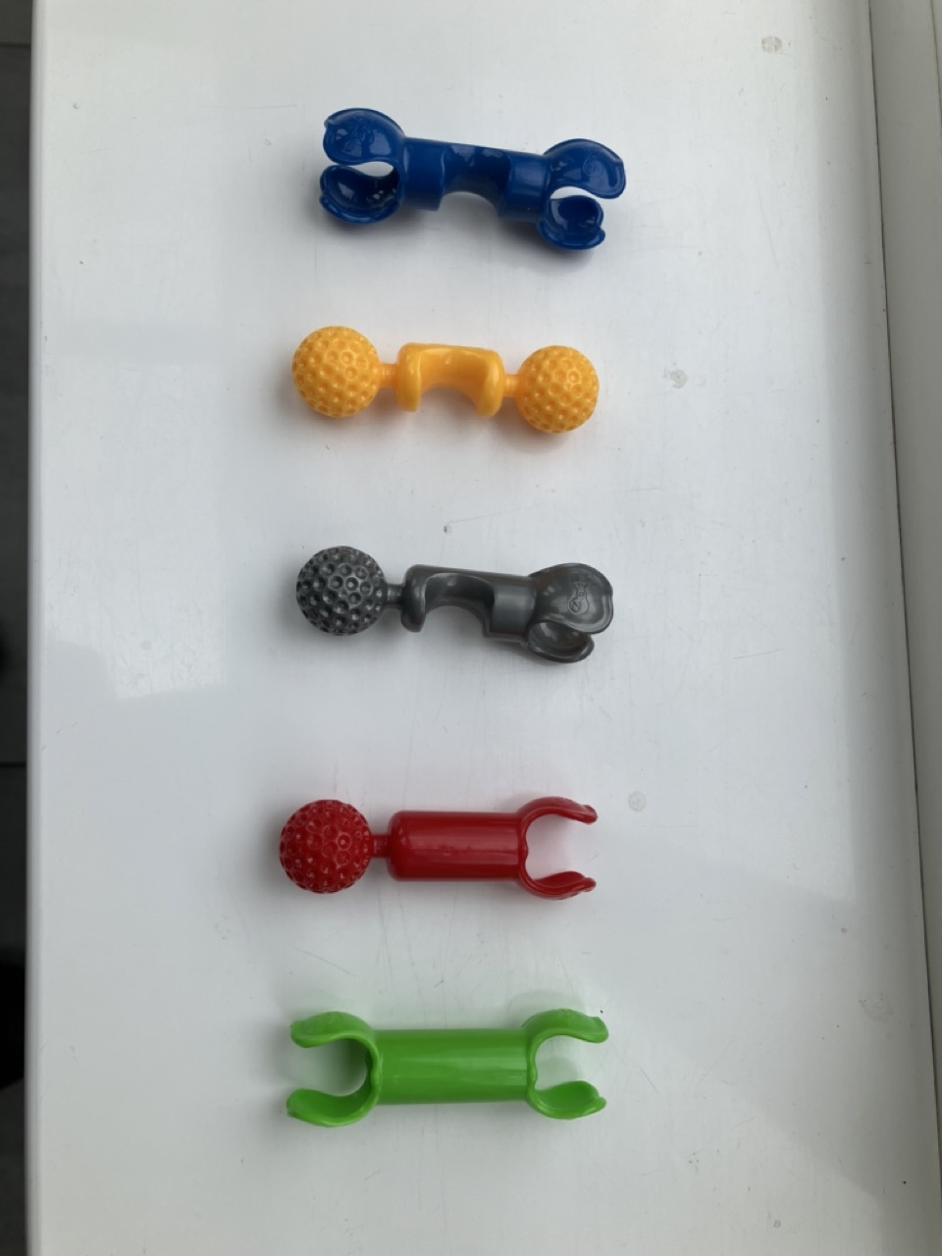
‘Construction Toy self-assembly’ is a hands-on activity about how building blocks assemble to form repeating patterns, just like the atoms in crystals.

Key information
Science topic(s): Crystallisation, Framework materials, Self-assembly
Age range: 5+, including adults.
Activity duration: 5 minutes- 30minutes
Health and safety considerations: Construction toy pieces may pinch fingers.
Special requirements: n/a

What do I need?
- A set of construction toy pieces, such as Lego, Duplo, k’nex or Octons, ideally with many multiple pieces of the same shapes/sizes/colours. We have found that Zoobs (the toy in the picture above) work well too.

What do I do?
- Try assembling a few pieces, thinking about how they connect.
- Try to make a regular, repeating pattern with the pieces. You are making a crystal!
- Can you make different patterns, perhaps with different types of pieces, or with the same pieces in different ways?
Did you notice?
What about each piece makes it able to connect with others?
How flexible are the connections between pieces? Dos this make it easier or harder to connect, compared to other types of connections (perhaps in other construction toys)
Did you know?
Atoms and molecules in crystals around us also connect in particular ways that influence the arrangement they make, and the appearance and properties of their crystals.
Different arrangements of the same building blocks are known as polymorphs.
Crystals are all around us, from metals and rocks to cellulose in plants and polymers in plastics. The Yeung research group at UoB is investigating how crystals form in materials known as ‘metal-organic frameworks’, which are a bit like the crystals you have made in this activity, but the building blocks (metal ions and organic linkers) around 10⁹ (a thousand million) times smaller!
In the real world, not all materials form crystals. Many common materials, including various plastics and types of glass, are amorphous, which means their molecules are arranged more randomly, which can influence their properties like transparency and flexibility.

Taking this activity further
This activity relates to other areas of science, including:
- Crystal growth
- Nucleation
- Framework materials
- Defects
- Epitaxial growth
- Amorphous materials



For more activities and information about the science behind this activity, visit YeungGroupBham.com/Outreach

Creative Commons licensing
© Hamish Yeung at UoB, 2024. This work is openly licensed via CC BY 4.0.

