  - Crystallisation of a Magic Crystal Tree
  - At Home

About this activity
‘Crystallisation of a magic crystal tree’ is an activity about crystals and crystal growth using a ‘magic crystal tree’. You can look closely at a growing magic crystal tree to see the crystals, which grow over the course of about four hours.

Key information
Science topic(s): Crystals, crystallisation.
Age range: 5+, including adults.
Activity duration: 2 minutes – 4 hours.
Health and safety considerations: Chemicals may irritate skin – wash hands immediately after setting the tree up and do not move or touch it.
Special requirements: Stable table surface.

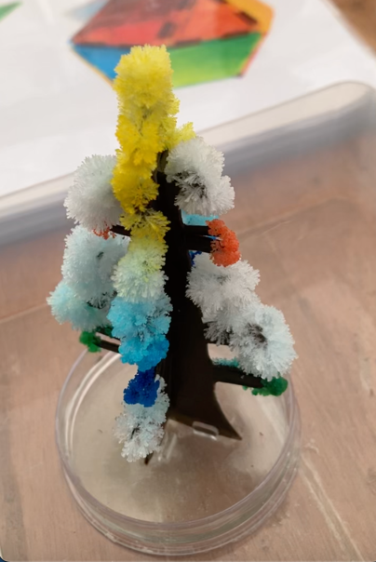

What do I need?
- A “magic” crystal tree kit, available from gift shops or online for a few ££.
- Optional: a magnifying glass.

What do I do?
- Assemble the tree: Unpack from its box, slot the two cardboard pieces together and stand them in the small tray provided. Place it on a larger tray (e.g., lid of a plastic box) to catch any spills.
- Position the tree: Place the tray and tree on a stable table surface, where it can be looked at but won’t get knocked. Once it starts to grow you won’t be able to move it!
- Dispense the solution (with adult help if needed): Carefully open the sachet of the crystal salt solution and pour it over the tray and cardboard tree. Wipe up any spills with damp paper towel and dispose of them.
- Cover the tree with a transparent cover, e.g., plastic box, so that you can see the tree but it is protected from accidental knocks.
- Wash your hands immediately after setting up the tree.
- Leave the tree to stand for a few hours until crystals start to form.
- Look at the magic crystal tree, using a magnifying glass if necessary, to see the crystals.
- Pack away by soaking up any remaining liquid solution with paper towel, and dispose of everything as household waste.

Did you notice?
Crystals have smooth facets and sharp edges – this is because they are made of atoms arranged in a regular, repeating pattern. This regularity means they have facets or can be cut in specific orientations (think of the cuts of a gemstone, such as diamond).
The crystals form from ammonium (NH₄⁺) and hydrogen phosphate (HPO₄⁻) ions, which start off dissolved in the water. As the water soaks up through the cardboard ‘branches’, the dissolved ions come with it. Where the water evaporates at the edges of the cardboard, the ammonium and hydrogen phosphate ions join up to form the crystals. As more water evaporates, more ions attach and the crystals grow!
The colour comes from pigments in the card that become drawn up with the water and stick on, or inside, the growing crystals.

Taking this activity further
This activity relates to other areas of science, including:
- Crystal structures
- Factors affecting crystallisation
- Supersaturation
- Nucleation
- Crystal growth
- Crystals in nature, e.g., gem stones, rocks.



For more activities and information about the science behind this activity, visit YeungGroupBham.com/Outreach

Creative Commons licensing
© Hamish Yeung at UoB, 2024. This work is openly licensed via CC BY 4.0.

