Jigsaw puzzle nucleation
At Home

About this activity
‘Jigsaw puzzle nucleation’ is a hands-on activity about crystal nucleation using jigsaw puzzles to show different ways a nucleus could form.

Key information
Science topic(s): Crystals, crystallisation, framework materials.
Age range: 3+, including adults.
Activity duration: 3-5 minutes
Health and safety considerations: N/A
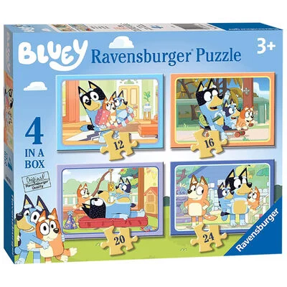
Special requirements: N/A

What do I need?
- Small jigsaw puzzle (12 or 16 pieces is ideal)
- Optional: Stopwatch timer (you could use the timer on a mobile phone)

What do I do?

- Take the jigsaw puzzle out of its box and build it! As you do so, think about if you are using anything to guide how you assemble the jigsaw puzzle?
Did you notice?
Did you find the corners first? Or start by assembling the edges? Or group similarly-coloured/patterned pieces before putting them together? Did you build it from one side to the other, or more randomly?
Nucleation is the initial step in crystallisation, which determines the final crystal’s structure. Similarly to assembling a jigsaw puzzle, there are different ways that atoms and molecules assemble: different nucleation pathways.
- Try re-assembly the puzzle using different methods, timing yourself to compare how long each way takes. Which way is quickest?

Taking this activity further
This activity relates to other areas of science, including:
- Defects in crystals (missing jigsaw pieces!)
- Crystal growth
- Factors affecting crystallisation



For more activities and information about the science behind this activity, visit YeungGroupBham.com/Outreach

Creative Commons licensing
© Hamish Yeung at UoB, 2024. This work is openly licensed via CC BY 4.0.

