Magnetic Tile Crystals
  - At Home

About this activity
‘Magnetic tile crystals’ is a hands-on activity about crystal structure using magnetic tile toys. Lots of people can get involved at once and create any type of structure, crystal-like or not.

Key information
Science topic(s): Crystals, crystallisation, framework materials.
Age range: 3+, including adults.
Activity duration: 5-30 minutes
Health and safety considerations: Magnetic tile pieces can pinch fingers if allowed to snap together quickly.
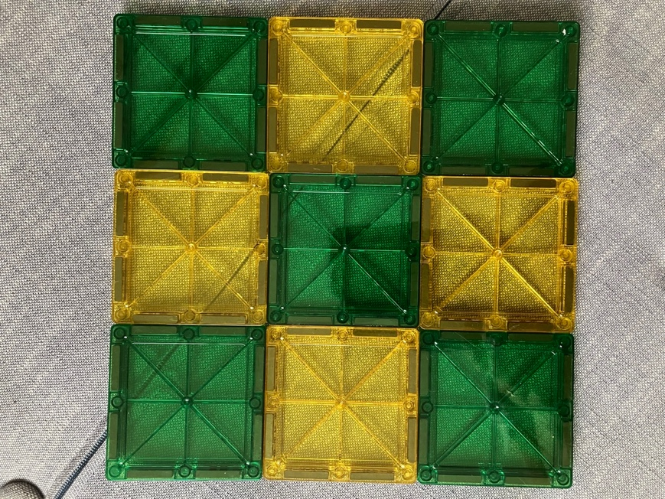
Special requirements: none

What do I need?
- A set of magnetic tile toys (e.g., “Magna-Tiles”).

What do I do?
- Try assembling the magnetic tiles – how do they connect?
- Can you make a regular and repeating pattern with the tiles? You could use one or more different shapes or colours…
- What different sorts of patterns can you make? 1-D, 2-D, or even 3-D?
Did you know?
Crystals are made of atoms and molecules arranged in a regular, repeating pattern. The shapes and sizes of the atoms and, crucially, the bonds they can make with other atoms define their arrangement in a crystal. This is much like the Magnetic Tiles’ different shapes and sizes and the places where they have magnets on their edges!
Crystals are all around us, from metals and rocks to cellulose in plants and polymers in plastics. The Yeung research group at UoB is investigating how crystals form in materials known as ‘metal-organic frameworks’, which are similar to magnetic tiles but the building blocks (metal ions and organic linkers) are around 10⁹ (a thousand million) times smaller.

Taking this activity further
This activity relates to other areas of science, including:
- Crystal growth
- Crystal defects
- Porous crystals

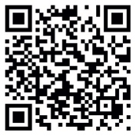

For more activities and information about the science behind this activity, visit YeungGroupBham.com/Outreach

Creative Commons licensing
© Hamish Yeung at UoB, 2024. This work is openly licensed via CC BY 4.0.

