Mineral Crystals
  - At Home

About this activity
‘Mineral Crystals’ is a hands-on activity about the size, shape and appearance of crystals around us.

Key information
Science topic(s): Crystals, crystallisation, framework materials, geology.
Age range: 2+, including adults.
Activity duration: 2 – 10 minutes.
Health and safety considerations: Crystals may have sharp edges. Swallowing risk for any small crystals (e.g., jewellery) – adult supervision recommended.
Special requirements: N/A
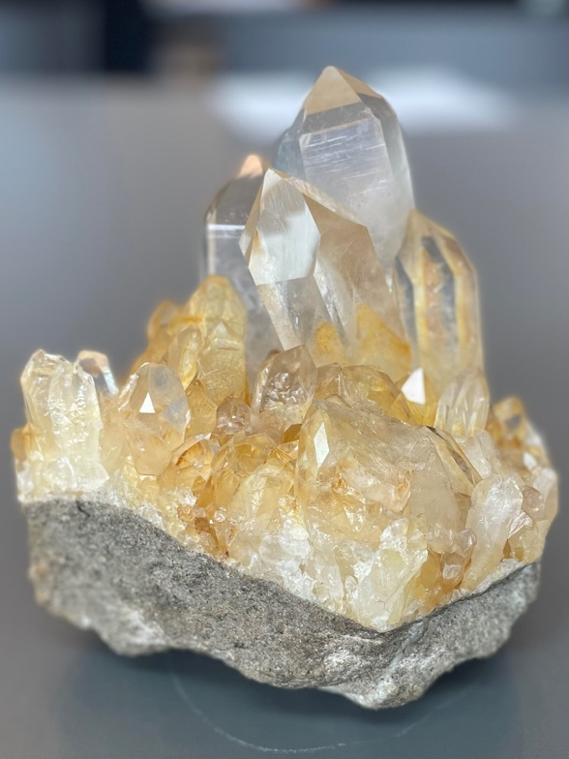

What do I need?
- One or more gemstones, such as found in jewellery, or bought in shops that sell crystals. Or you can make your own from sugar (for instructions, see the CCDC activity resource https://www.ccdc.cam.ac.uk/community/education-and-outreach/outreach/science-festivals/crystals-of-sugar/)
- Optional: a magnifying glass.

What do I do?
- Look at the shape and colour of the crystals. Use a magnifying glass to look close-up.
- Think about why the crystals might have their particular shape, size or colour. Are the surfaces flat and shiny or dull or rounded? Why might this be?
- Discuss the differences between any different crystals you have.
- Make sure you give back any borrowed crystals (e.g., adults’ jewellery) when you are finished!

Did you notice?
Crystals have smooth facets and sharp edges – this is because they are made of atoms arrange in a regular, repeating pattern. This regularity means they have flat, smooth facets and sharp edges, and they can be cut in specific orientations (think of the cuts of a gemstone, such as diamond).
Different crystals may have different appearances because they are made from different atoms or molecules, which may be arranged in different ways.
Different colours can come from the presence of tiny amounts of other atoms included in the crystal structure, which cause certain colours of light to be absorbed by the crystal!
Crystals are all around us, from metals and rocks to cellulose in plants and polymers in plastics. Next time you are out and about, look closely and try to spot any crystals around you!

Taking this activity further
This activity relates to other areas of science, including:
- Crystal growth
- Geology
- Defects
- Impurities
- Framework materials

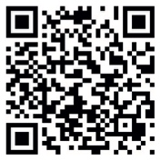

For more activities and information about the science behind this activity, visit YeungGroupBham.com/Outreach

Creative Commons licensing
© Hamish Yeung at UoB, 2024. This work is openly licensed via CC BY 4.0.

